
WFNJ - Care Coordination Services
MEMO

To: All NCADD-NJ Care Coordination Staff

From: Stacey Wolff, Director of Care Coordination Services

CC: Luci Doppler, Clinical Director

Date: April 2015

Re: POLICY REVISION: Extended Evaluation Protocol

(Add to “Policy Update Memo” Section of Program Manual)
____________________________________________________________________________________

Identifying the Need for Extended Evaluation Services:
All GA or TANF clients who do not meet the criteria for a substance abuse disorder, should have a deferred diagnosis and be placed in a 30-day Extended Evaluation (EE). The EE is intended to either facilitate a substance use disorder diagnosis and level of care recommendation or conclusively rule out a substance use disorder (Treatment Not Indicated or “TNI”). During the 30-day EE period, the client may be referred to Level I ‘discovery’ outpatient services (if the county has a provider who offers this level of service), with one weekly urine drug screen (UDS), or the client may be referred to a 4-week “UDS only” EE where Level I discovery services are not available. Throughout the EE, the Care Coordinator (CC) monitors the client’s treatment participation, drug screens, attendance, and also collects collateral information from independent sources who can provide additional information regarding the client’s possible substance use. The CC is responsible for reading previous episodes of care to identify a history of substance use.
- Clients referred for an extended evaluation should also be referred for an assessment UDS, the assessment UDS would count as the first of four EE urine screens.
- All clients who come in through the “BHI” referral process who have a history of substance abuse or a previous Episode of Care with the WFNJ SAI/BHI and deny current use should be sent for an extended evaluation.
The CC asks the client to sign releases of information permitting communication with collateral sources and for the EE provider. The CC explains to the client that he or she will be referred for the extended evaluation over the course of the next 30 days that will include either Level I services (if available) and 4 monitored UDSs, or 4 UDSs without Level I services. The client will be required to sign an EE Agreement and will be given a copy.

ASAM Documentation of EEs:
- For UA-Only EEs where you DO NOT suspect the client of having a substance use disorder, you should select “UA” in the drop-down for ASAM Level Assessed and “UA in the dropdown for ASAM Level Placed. This will permit you to select EE. You do not create a PPL for the UA-only clients.

- For UA-Only Opioid Extended Evaluations (OEEs), for OMT, where you DO NOT suspect the client as having a substance use disorder beyond opioids, on the ASAM Note you would select “OMT” in the drop-down for ASAM Level Assessed and “OMT” and in the dropdown for ASAM Level Placed (1) and “UA” in the dropdown for ASAM Level Placed (2). This will permit you to select OEE. You do not create a PPL for the UA-only OEE clients.

- If the client is already in treatment at an OMT provider, DO NOT send the client for four urine drug screens, you will ask the client to sign a release and you will request that the OMT provider send you the client’s last four UDS results. On the ASAM Note, select “OMT” in the drop-down for ASAM Level Assessed and “OMT” and in the dropdown for ASAM Level Placed (1) and “UA” in the dropdown for ASAM Level placed (2). This will permit you to select OEE. You do not create a PPL for the UA-only OEE clients.
- If you suspect the client DOES have a substance use disorder but the client denies drug or alcohol use, and they are not seeking OMT, and you do not have a Level I EE provider in your county but you assess them to need Level 1 or a greater level of service, you would select the true ASAM Level Assessed from the dropdown and then select “UA” in the ASAM Level Placed. This will permit you select the EE box.
- If you suspect the client DOES have a substance use disorder, but the client denies drug or alcohol use and they are seeking OMT, you will select the true ASAM Level Assessed and Level placed would be OMT and UA as above, this will permit you to select “OEE.”
- For EE clients who are sent to a level 1 provider, you will select the true ASAM Level Assessed and the Level 1 in the ASAM Level Placed. You must create a Level 1 PPL for these clients and obtain attendance and UDS results. You do not select “UA” as the second level placed and you do not select “EE,” this client is considered a Level 1 client at this point, and not an EE, even though it is only for four weeks.

The CC completes and asks the client to sign a copy of the “Extended Evaluation Agreement” that clearly indicates the days and time that the client is scheduled to attend treatment. In addition, the CC refers the client for a full-time WFNJ work activity (provided the client is not work-deferred).

When the CC refers the client to the EE Level 1 provider, he or she faxes the completed WFNJ SAI/BHI referral packet including the EE Admission Letter, creates a PPL for Level 1 and follows the protocol for level I treatment. The CC explains to the provider that the client currently denies a substance use disorder but is being referred for services to either rule out or facilitate a diagnosis and the need for further treatment. The CC instructs the Level 1 provider to report weekly treatment attendance and UDS results to the WFNJ-SAI/BHI PA Unit. Extended evaluation services may be preapproved for no more than two weeks at Level 1 to ensure frequent communication between the CC and the treatment provider.

If the EE provider is not providing Level 1 services, the CC will instruct them to fax the UDS results directly back to the CC on the UDS Request Form, the CC will follow the WFNJ SAI/BHI procedures for utilizing the UA module for each weekly EE UDS including generating a UA Payment Authorization.

Important!! Determining the Results of the Extended Evaluation and Case Closure Choices:

- If the client is sent for 4 urine screens only, and they are all negative, and it is determined that treatment is not indicated, the client’s WFNJ SAI/BHI case is closed with a closure choice of “Treatment Not Indicated.” The client is referred to a full-time work activity (if not work deferred). If the client has an open DCP&P case, the CC also notifies DCP&P of the results of the extended evaluation and advocates on the client’s behalf with DCP&P. For DCP&P clients who are not in need of treatment services, they will be monitored for 30 days per the Work Activity Monitoring policy.
- If the client is sent for a Level 1 EE and completes the 4-week treatment plan and all UDSs are negative, the CC will close the case as “Successful Discharge.”
- If it is determined that the client is in need of treatment by failing ONE UDS or not attending individual or group sessions, the CC notifies DCP&P (if applicable) of the positive UDS result(s) and the recommended level of care. The CC meets with the client and employs motivational counseling techniques to encourage the client’s participation in the recommended level of care.
- When closing the case for a client who fails to complete the “UDS Only” EE, the case closure status should be “Assessment Not Completed.”
- If the client fails to complete a Level 1 EE the case closure status should be “Client Dropped Out,” or if they did not show for the Level 1 intake appointment the case closure status should be “Refused Treatment.”

Circumstances when a client should NOT be sent for an EE or should not complete an EE:

- If a client had an Episode of Care with the WFNJ SAI/BHI that required treatment within one year of the current referral date, the client should be sent to treatment, not an EE.
- If a client tests positive for one UDS at any point during the EE, he or she should not be sent for another UDS, they must be sent for treatment.
- If a client refuses to submit a UDS, the client should be offered treatment services.
- If the client misses two consecutive scheduled UDSs, the client should be brought in and referred for treatment.
- If the client admits to substance use, do not send them for an EE or OEE, they should be referred to treatment.

If the client fails to complete the extended evaluation within 4 weeks, after being outreached, the client should be closed and referred for a welfare sanction. EE cases should never remain open beyond 5 weeks.

ASSESSMENT EE/OEE MODULE

This module will be used for all EE, OEE, and Assessment urine drug screens when a PPL will not be created. The CC is responsible for entering all Assessment UDS and EE UDS-only results and creating the Payment Authorization.

- Search for a client and verify that you are in the client’s current EOC.
- Select “Treatment” from the main menu bar.
- Select the “Assessment EE/OEE UDS” option from the side menu.

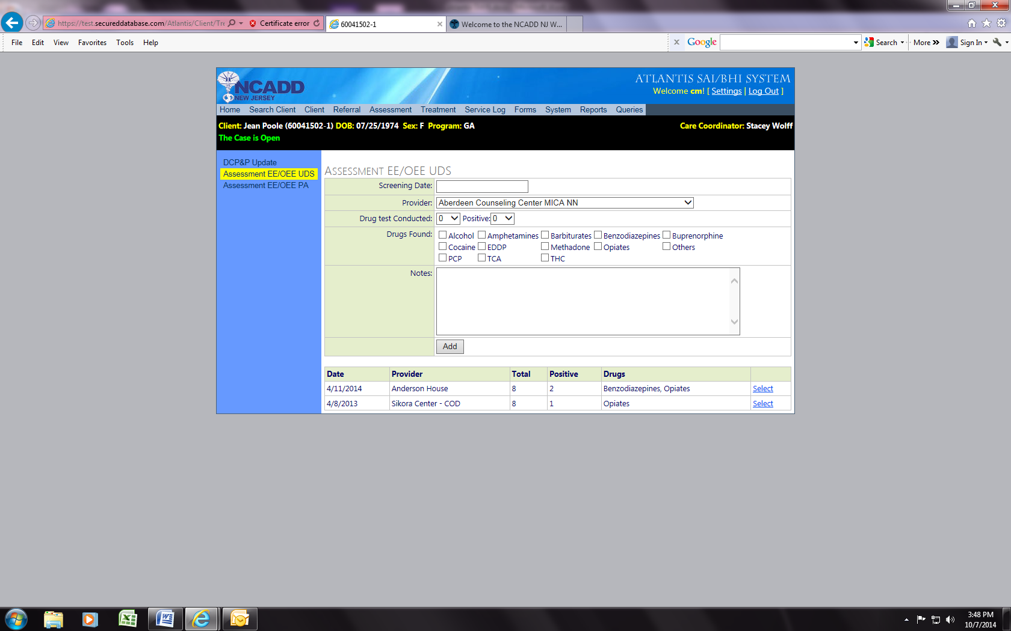

- Enter the screening date (the date that the urine specimen was COLLECTED by the provider, not received by you).
- Select the treatment provider who provided the UDS from the “Provider” dropdown.
- Enter the number of tests conducted (this is how many substances the client was tested for; it is often 7-10). This number is automatically defaulted to “0.”
- Then enter the number of substances the client tested positive for (up to 10). If you choose a number for ‘positive’ you must check off which substances the client tested positive for. This number is automatically defaulted to “0.” Do not change this number if the client was negative.
- You can write any additional information that is significant in the "notes" section.
- Then click "Add" to save the results.
- Once the UDS results have been saved, you then select the “Assessment EE/OEE PA” menu option to begin creating the EE/OEE payment authorization.
- Select the treatment provider who provided the UDS from the “Treatment Provider” dropdown.
- The “Diagnostic Impression” (DSM IV-TR/5 Diagnostic Impression) code(s) found on the client’s initial ASAM Note automatically pulls through to the "Axis I Diagnosis" field.
- Enter the dates in the "Authorization Period From" and “To” date fields. This date will be the date of the UDS. For example, if the UDS was conducted on 9/24/14, the authorization dates would be from 9/24/14 to 9/24/14.
- In each of the boxes below for “units requested, units approved” enter "1." The system will automatically calculate the fee requested and fee approved amounts in the corresponding boxes.
- Then click "Add."

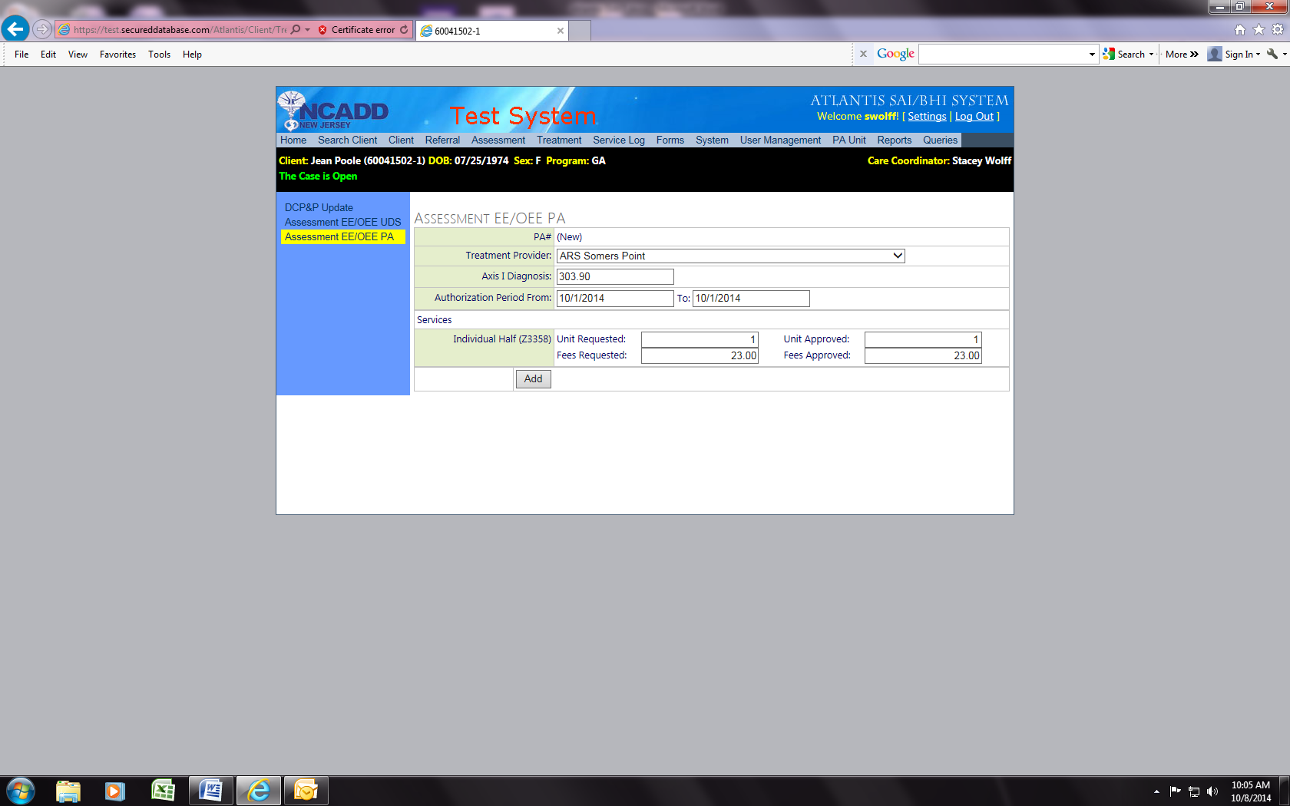

- Your Assessment EE/OEE Payment Authorization has been successfully created.

