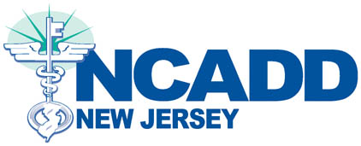
Payment/Reimbursement Agreement
for LPC/ LCSW Supervision

This agreement is made between NCADD-NJ, Inc. and the
Employee as named below.

In accordance with the terms and conditions as stated in the LPC and LCSW Payment and Reimbursement Program, the employee agrees to reimburse NCADD-NJ, Inc. for all costs, on a prorated basis, associated with supervision for the LPC and/or LCSW should employment be terminated either voluntarily or involuntarily in less than 12 months from the effective date of the above referenced licenses or should employment be terminated either voluntarily or involuntarily prior to obtaining the license.

I understand that the total amount owed, as per the Payment and Reimbursement Program, will become due and payable immediately upon voluntary or involuntary termination of employment unless at least 12 months have elapsed since the effective date of the license obtained.

I agree to the terms as stated above.

___________________________
Employee Name

___________________________ __________
Employee Signature Date

