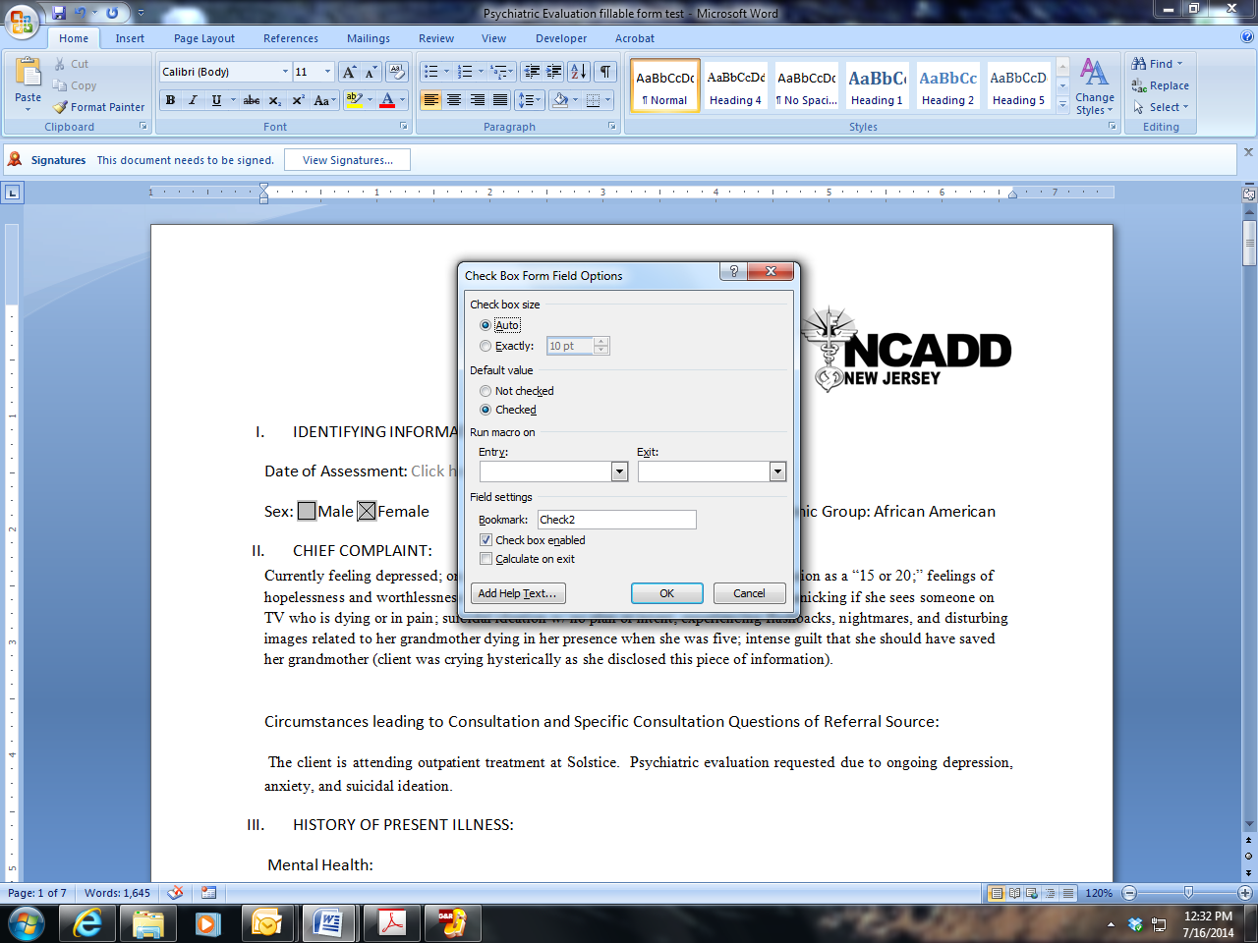

Instructions for entering information in the Psychiatric Evaluation

**TO FILL CHECK BOXES**

You must double-click on left side of mouse and select “Checked” under Default Value, and then click “ok.”

**TO ENTER TEXT**

Use your mouse to click on the text box next to each question that says:

**Click here to enter text.**

Psychiatric Evaluation

1. IDENTIFYING INFORMATION: Click here to enter text.

Date of Assessment: Click here to enter text.

Sex: Male Female Age: Marital Status: Ethnic Group:

1. CHIEF COMPLAINT:

Click here to enter text.

Circumstances leading to Consultation and Specific Consultation Questions of Referral Source:

Click here to enter text.

1. HISTORY OF PRESENT ILLNESS:

Click here to enter text.

Mental Health:

Click here to enter text.

Substance Use History: (substances, quantity, frequency, longest period of abstinence and date of last use)

Click here to enter text.

1. PAST PSYCHIATRIC & SUBSTANCE TREATMENT HISTORY: (Include any outpatient treatment and interventions, with dates, such as Individual Therapy, Family Counseling, Group, etc.)

Click here to enter text.

Mental Health:

Click here to enter text.

Substance Use Disorder:

Click here to enter text.

1. MEDICAL/SURGICAL HISTORY:

Click here to enter text.

Allergies: Yes No If yes, please specify: Click here to enter text.

Past Medications & Current Medications: Click here to enter text.

1. PSYCHOSOCIAL/DEVELOPMENTAL/FAMILY HISTORY OVERVIEW:

Click here to enter text.

1. SPIRITUAL AND RELIGIOUS CONSIDERATIONS:

Click here to enter text.

1. SUICIDE RISK ASSESSMENT:
2. Are you having thoughts of killing yourself? Yes No

If yes, do you have a plan? Yes No

If yes, describe plan: Click here to enter text.

1. Have you ever attempted to kill yourself? Yes No

If yes:

1. When?
2. Were you intoxicated at the time? Yes No
3. Where were you?
4. Was anyone else there at the time?
5. Who found you?
6. Were you hospitalized as a result of the attempt? Yes No
7. How did you feel when you realized you hadn’t succeeded? (i.e. Were you upset that you weren’t dead or were you happy that you’d survived the attempt?)
8. What prevented you from attempting again?
9. Do you have a history of overdose, accidental or intentional? Yes No

If yes, please explain (number of times, date/dates, method of overdose, etc.):

Click here to enter text.

1. Suicide Risk Factors (check all that apply):

|  |  |
| --- | --- |
| Current ideation, intent, plan access to means | Previous suicide attempts |
| Alcohol/Substance abuse | Previous history of psychiatric diagnosis |
| Impulsivity and poor self control | Hopelessness |
| Recent losses – financial, physical, personal | Anniversary of important loss |
| Co-morbid health problems, especially newly diagnosed problem or worsening symptom | Age, gender, race (elderly or young adult, unmarried, white, male, living alone) |
| Trouble with the law | Gambling problems |
| History of abuse (physical, sexual, emotional) | Family history of suicide |
| Family of origin violence | Domestic partner violence |
| Same-sex orientation | Recent discharge from an inpatient unit |

1. Suicide Protective Factors (check all that apply):

|  |  |
| --- | --- |
| No previous suicide attempt | No plan, intent, or access to means |
| Hopeful about the future | Good social support from friends and family |
| Close family relationships | Pregnancy |
| Responsible for children under 18 years old | Living with another person, especially a relative |
| Healthy relationship with partner | Ability to cope with stress, crisis and loss |
| Good physical health | Strong spiritual or religious faith |
| Early identification and treatment of mental illness | Employed |
| Positive therapeutic relationship |  |

1. OTHER CONDITIONS THAT MAY BE A FOCUS OF CLINICAL ATTENTION (Occupational Problems, Medical, Legal, Homelessness, Environmental, etc.):

Click here to enter text.

1. MENTAL STATUS EXAMINATION (Check All Symptoms Present):
2. Appearance:

|  |  |  |
| --- | --- | --- |
| Neat | Disheveled | Malodorous |
|  | Relaxed | Chronically Ill |
| Poorly Groomed | Well Groomed | Emaciated |
| Casually Dressed | Age Appropriate | Little Facial Expression |

Other/Comments: Click here to enter text.

1. Speech:

|  |  |  |
| --- | --- | --- |
| Paucity of Speech | Rapid Speech | Fluent Speech |
| Scanning Speech | Slurred Speech | Other |

Other/Comments: Click here to enter text.

1. Attitude:

|  |  |  |
| --- | --- | --- |
| Cooperative | Tense | Hostile |
| Volunteers Little Info. | Suspicious | Grandiose |
| Uncooperative | Guarded | Positive |
| Friendly | Evasive | Resistant |
| Relaxed | Other |  |

Other/Comments: Click here to enter text.

1. Mood:

|  |  |  |
| --- | --- | --- |
| Anxious | Dysphoric | Neutral |
| Hostile | Fearful | Angry |
| Subdued | Elated | Apprehensive |
| Irritable | Content/Context Appropriate | Content/Context Inappropriate |

Other/Comments: Click here to enter text.

1. Affect:

|  |  |  |
| --- | --- | --- |
| Full Range | Intense | Constricted |
| Restricted | Fearful | Labile |
| Blunted | Detached/Apathetic |  |

Other/Comments: Click here to enter text.

1. Self and/or Other Aggressive/Destructive Thoughts and Behaviors:

Homicidal Ideation Yes No Plan Yes No

Self Destructive Behaviors Yes No Plan Yes No

Other/Comments: Click here to enter text.

1. Thought Form:

|  |  |  |
| --- | --- | --- |
| Hallucinations | Auditory | Visual |
| Tactile/Touch | Olfactory/Smell | Gustatory/Taste |
| Coherent | Logical | Relevant |
| Delusions | Paucity of Thinking | Blocking |
| Intrusive Thoughts | Rumination |  |

Other/Comments: Click here to enter text.

1. Thought Content If checked, describe

|  |  |  |
| --- | --- | --- |
| Hallucinations | Paranoid Thinking | Obsessions |
| Delusions | Magical Thinking | Compulsions |
| Preoccupation |  |  |

Other/Comments: Click here to enter text.

COGNITIVE ASSESSSMENT:

1. Orientation:

Oriented To Person  Oriented To Place  Oriented To Time

Other/Comments: Click here to enter text.

1. Learn Three Objects (e.g. 3 feathers, 11 envelopes, 29th Avenue):

3 of 3 Correct  2 of 3 Correct  1 of 3 Correct  0 of 3 Correct

Other/Comments: Click here to enter text.

1. Repeat Three Objects (see “B”):

3 of 3 Correct  2 of 3 Correct  1 of 3 Correct  0 of 3 Correct

Other/Comments: Click here to enter text.

1. Memory:

Immediate Recall  Intact  Impaired

Short Term  Intact  Impaired

Long Term  Intact  Impaired

Other/Comments: Click here to enter text.

1. Impulse Control:

Average  Above Average  Below Average

Other/Comments: Click here to enter text.

DSM-5 DIAGNOSTIC IMPRESSION:

Click here to enter text.

Clinical Observation to support the Diagnostic Impression:

Medications Prescribed:

Click here to enter text.

CONSULTATION SUMMARYAND TREATMENT RECOMMENDATIONS



Print Name - Credentials

Date: