Assessment UDS Policy Update 9/26/19:

The Screening Tool that accompanies all referral packets is no longer used by the ACCs to determine SAI or BHI in the Referral Screen. The ACC must adhere to the selection (substance abuse=SAI or mental health=BHI) on the WFNJ-125 Referral form that is sent by the County. The ACC will then enter either SAI or BHI based on the referral only. See below:

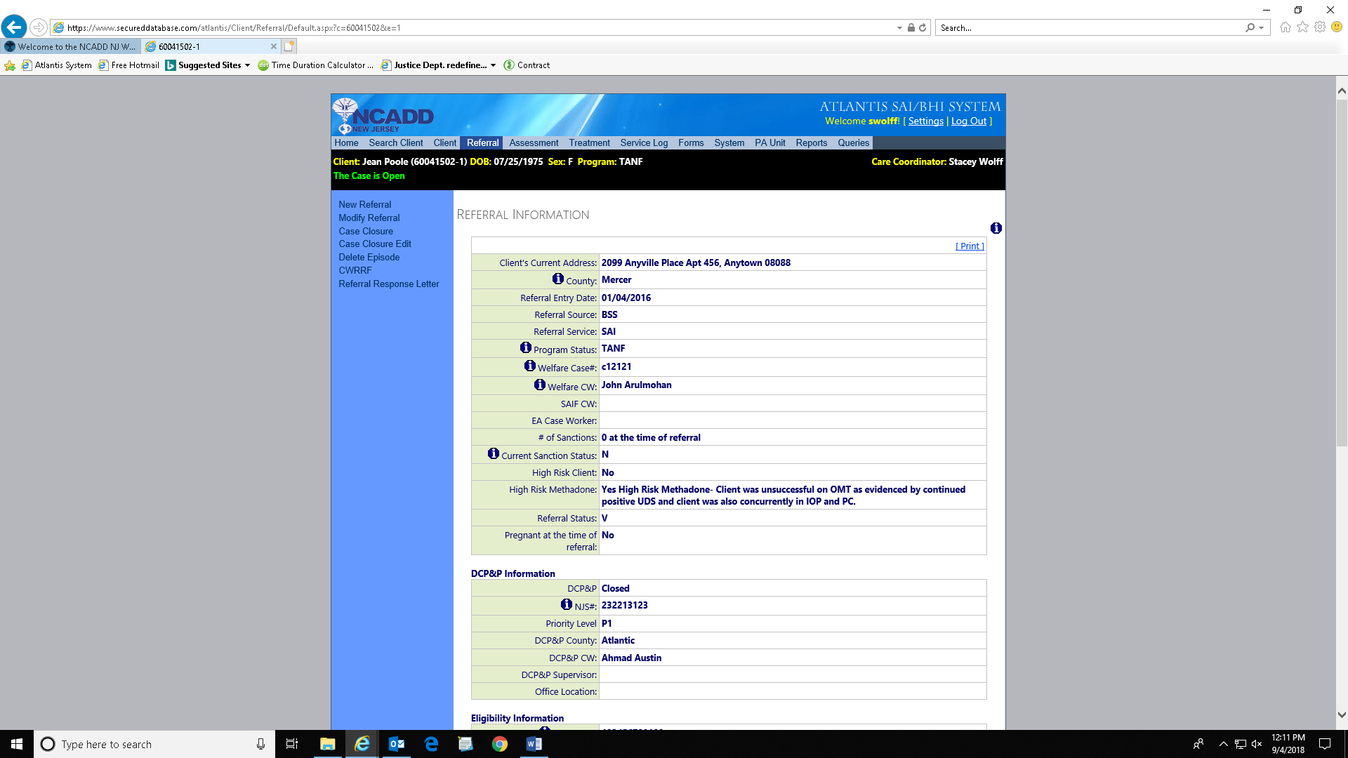

**Only DCPP-involved clients and those clients who are referred by the counties who are designated as “SAI” can be sent for an assessment urine drug screen (UDS). “BHI” designated clients will not get an assessment UDS**.

If a BHI-referred client has current substance use or a history of substance use, they can and should be sent for co-occurring treatment and begin weekly urine screens as part of their services.

If DCPP requests an extended evaluation, this is the only time it will be permitted. Per policy, all extended evaluations requested by DCPP must be documented in the service log.

As always, a client must have an active Medicaid number before he or she is sent for an assessment UDS or treatment.